SAFFRON SPY: READER RESOURCE

Book Cover & Description
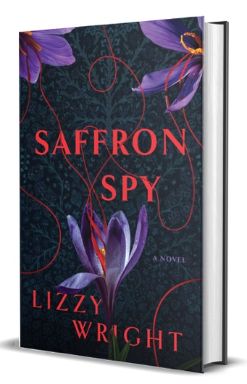
“Wyatt is dirty. Get out. Tonight.”
The anonymous warning reaches CIA analyst Lexi Boyd’s burner phone minutes before her husband’s hands close around her throat. She escapes, but cannot outrun a question more haunting than the attack: how did she miss the signs?
Self-doubt follows her into an operation targeting Maman, an elusive Iranian extremist, and into the orbit of Farid Shirvani, a magnetic exile whose charm conceals motives she cannot fully decipher. She’s been wrong about a man before. She cannot afford another mistake.
From Dubai’s shadow markets to the Strait of Hormuz and Iraq’s Valley of Peace, Lexi pursues Maman. But there’s a covert campaign unfolding beneath the operation: manufactured intelligence designed to justify war on Iran. Exposing the truth violates her oath. Staying silent means innocent people die. With Lexi’s loyalties at odds, there’s no clear path forward and no absolution.
Written by a former NSA counterterrorism analyst who spent years tracking Osama bin Laden, Saffron Spy trades certainty for a darker reckoning with moral injury, institutional betrayal, and the cost of choosing between conscience and country.

Author Bio


Lizzy Wright is a former counterterrorism analyst at the National Security Agency, where she spent years tracking Osama bin Laden and his inner circle. Her espionage fiction draws on that firsthand experience, exploring moral compromise, institutional secrecy, and the psychological toll of intelligence work.
She is the award-winning coauthor of Aggressively Human and Marinovich. Her work has been featured in USA Today, the Guardian, the Los Angeles Times, Sports Illustrated, and on the BBC World Service, SiriusXM Radio, CBS 8 News, KTLA, KUSI, and FOX 5 DC.
A graduate of Harvard and Georgetown, Lizzy finds creative clarity in the ocean. Much of her writing takes shape in the surf lineup, where she contemplates character, consequence, and the hidden currents that drive human behavior. She lives in Del Mar, California, with her husband, former NFL player Steve Wright.

Purchase Links
Amazon: https://a.co/d/0fgMNNfJ
Bookshop: https://bookshop.org/p/books/saffron-spy/4d5010ce87de5338?ean=9798897474332

Website & Social Media Links
https://www.lizzywright.com
https://www.facebook.com/AuthorLizzy/
(@_lizzy_wright) https://www.instagram.com/_lizzy_wright/
https://www.linkedin.com/in/lizzywright
https://www.youtube.com/@WrightAuthorBooks

Additional Promotional Materials

